Young Professionals in Infrastructure (YPI) Fellowship Program
The purpose of the YPI Fellowship Program is to provide graduate students focused on infrastructure research with the opportunity to engage with professionals in the infrastructure sector to help further their active academic research and allow them to communicate the product of their study and academic achievement in conferences and other academic and industry forums. YPI recognizes the importance of ensuring that the infrastructure industry and academia engage in regular communication to further common goals and hopes to provide high achieving individuals with the opportunity to network with the various YPI member organizations.

The YPI Fellowship will provide Fellows with funding that can be applied to costs such as travel and registration costs in order to attend conference(s) and/or other industry event(s), and/or fees to access various P3 data repositories related to their proposed research for the fellowship. Grants of up to $5,000 will be awarded to one or more YPI Fellows.

In addition to facilitating opportunities for meaningful engagement with industry and academia, Fellows will partner with YPI on a research project. This project will be proposed by applicants as part of the application process and can vary in terms of topic and scope, but should focus on a subject within the Infrastructure/P3 field.

Fellowship Application Criteria and Process:
- Current graduate student (e.g., MA, MS, MBA, MPA, MPP, PhD or JD candidates or equivalent degrees)
- Student is undertaking, or has a desire to undertake, research on infrastructure, with a connection to innovative/alternative project delivery (i.e., procurement, financing, design, construction) or P3s
- Applications will be evaluated by a panel of YPI members

Application Details:

Applications for 2024 are due March 31st, 2023

Please submit any questions and final applications (in Word or PDF) to
general@ypinfrastructure.com.

Questions:

- General Questions
  - What interests you about Infrastructure/P3s? (150 words)
  - Describe any prior knowledge of and experience with Infrastructure/P3s, including through internship/work experience, courses taken, research papers, etc. (this excludes ongoing research) (150 words)
  - What are some of the key research areas regarding P3s that need to be explored in future? (key improvement areas) (150 words)
  - What are your current intentions post-graduation, and particularly as it relates to the infrastructure and P3 industry? (150 words)Please describe the relationship between the equity provider, debt provider, contractor, and public sector in a P3. (150 words)
  - Please attach your resume.

Research Topic
  - Explain your current MS/PhD research on Infrastructure/P3s including the need for your research and how it is contributing towards the development of infrastructure or P3 industry (300 words).
  - What is your MS/PhD research schedule and tentative completion time? Please note that the YPI Fellowship will begin in January and conclude in December culminating in a presentation to YPI members. (150 words or a schedule)

Contribution to YPI
  - Please describe one or two main research projects that you propose to work on during the Fellowship year.
    - Provide research topic, introduction, objectives, methodology etc. for the research project(s) (not more than 300 words)
    - Explain how your research is contributing towards development of YPI and/or the Infrastructure/P3 industry (150 words)
  - Describe how you would propose to utilize the YPI Fellowship funding.
    - Provide details of your plan to utilize the YPI Fellowship grant towards your YPI research project. This should include (at a minimum) different activities along with an approximate amount for each activity and the associated timeline.
    - Additionally, what information, data, support, etc. would you envision being necessary from YPI to complete the project?
  - Please include any other feedback you deem relevant to this application for the review of the selection committee.

Fellowship applicants are encouraged to sign up to see us at upcoming YPI events by visiting https://ypinfrastructure.com/join/#subscribe
https://www.linkedin.com/company/young-professionals-in-infrastructure-llp/

Executive Organizational Members

Standard Organizational Members

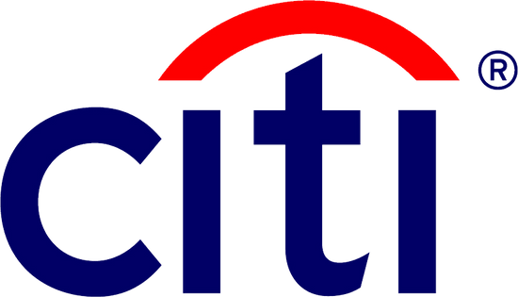

Public Sector Organizational Members

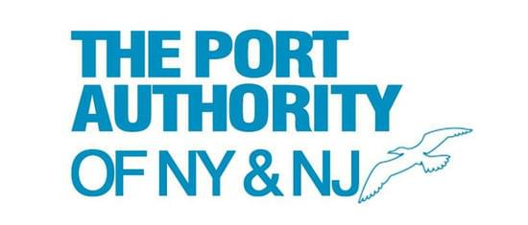

Academic Partners

Strategic Partners

